**Backyard Cinema**

**Process**

Once online, patrons will need to fill out a form to create their accounts. After the accounts have been created and their usernames (email address) and passwords have been entered, then they will be presented with a number of pictures. Each picture represents a theatre currently owned by Backyard Limited. These pictures are arranged in a tabular format (rows and columns). When the patrons click on one of the pictures, they are then presented with a number of pictures which are represented as movies associated with that theatre viewed in tabular format. Once they select a movie, they are then presented with not only the picture of the movie but also information such as schedule , ticket price, available seats and a rating meter that will be displayed below the picture along with a short synopsis of said movie. After which they have the option to decide whether they want to purchase a ticket and/or give a rating to the movie.

The managers of Backyard Limited will be assigned a username and password, however they can choose to change the password when needed given that they provide their ID number as a security key. After entering their default username and password, they are presented with the same tabular pictures of movie theatres as did the patrons. However, unlike the patrons, the managers are provided with a button to add a movie theatre to the list. There are four buttons above each theatre picture and each of these buttons serve a different function. One button allows the manager to add movies to their respected theatre. Another button deletes the chosen movie, while another allows the manager to make changes to the movie schedule, ticket prices, seating, the movie synopsis etc. The final button allows the manager to view revenue information as well as information involving patrons.

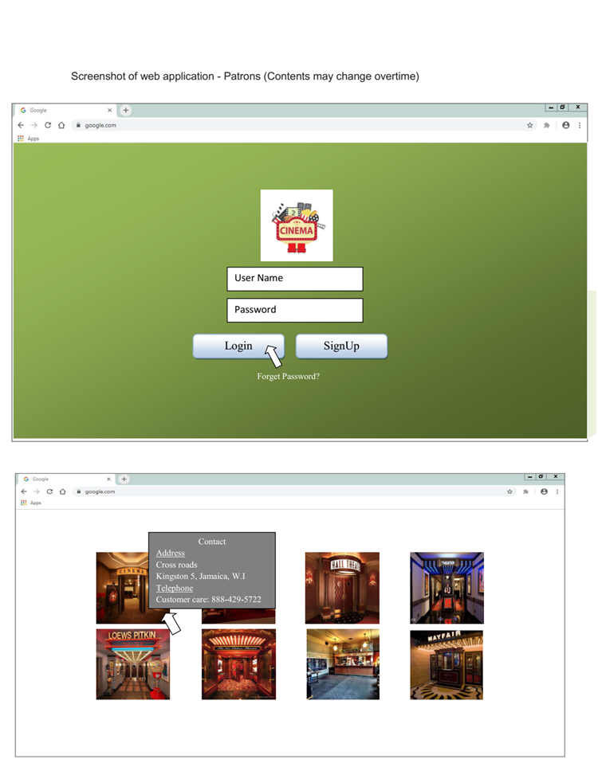

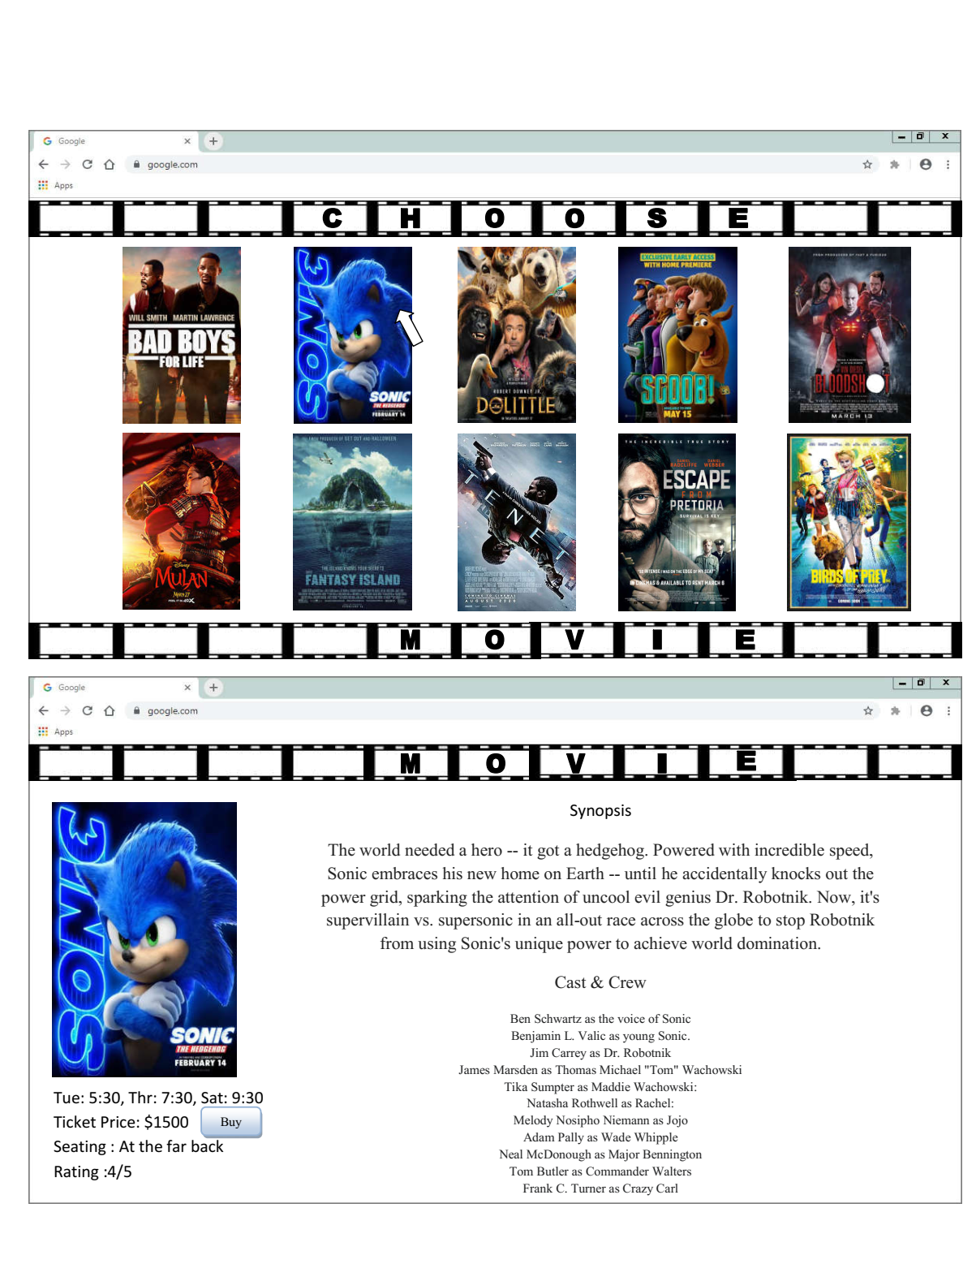

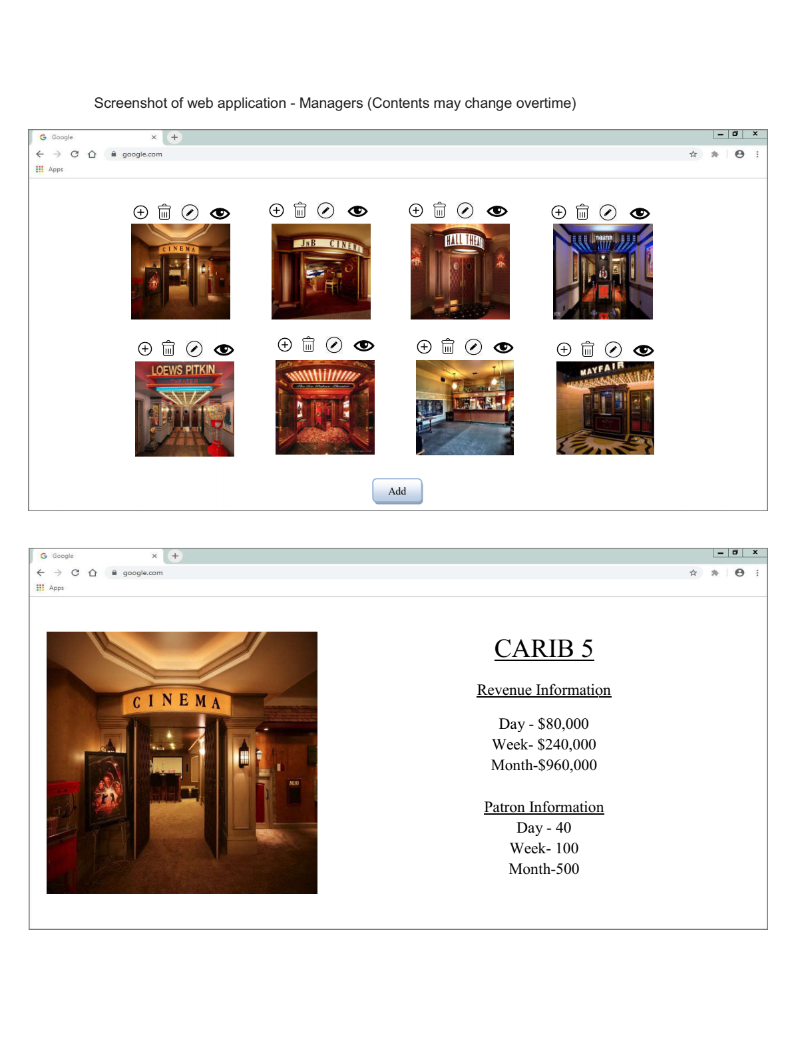

**Features**

Operating System: earliest windows 8.81 latest windows 10

Hard drive: 3 Terabytes

RAM: 128 Gigabytes

LAN Enabled?: Yes

Compatibility with User interface? Yes

Processor: 2.4 GHz or faster; cache 64MB; cores 4

Architecture: x64

BIOS mode: legacy

**Basic Operation**

To gain access to theatres and select movies of your choice.

**Technical Support**

**End users are to contact our software team for any support. If errors still exist after troubleshooting, contact us at 1(876) 539-9034.**